**PRACTICAL-1**

**Aim**-**program to swap two variable using pointer.**

**Input:-**

#include<stdio.h>

void swap(int *a , int *b)

{

int c;

c=*a;

*a=*b;

*b=c;

}

int main()

{

int num_1,num_2;

printf("enter the number 1:");

scanf("%d",&num_1);

printf("enter the number 2:");

scanf("%d",&num_2);

printf("before swaping : \n num_1 is: %d \n num_2 is: %d\n",num_1,num_2);

swap(&num_1,&num_2);

printf("after swapping :\n num_1 is : %d\n num_2 is : %d\n",num_1,num_2);

return 0;

}

**Output:-**

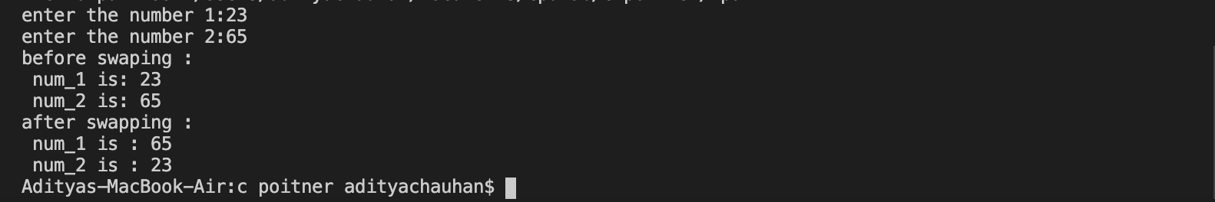

**PRACTICAL-2**

**Aim**-**program to print different types of pointer.**

**Input:-**

#include<stdio.h>

int main(){

printf("\n size of int pointr : %lu",sizeof(int*));

printf("\n size of float pointr : %lu",sizeof(float*));

printf("\n size of char pointr : %lu",sizeof(char*));

printf("\n size of long pointr : %lu",sizeof(long*));

printf("\n size of double pointr : %lu",sizeof(double*));

printf("\n size of long int pointr : %lu",sizeof(long int*));

printf("\n size of long double pointr : %lu\n",sizeof(long double*));

return 0;

}

**Output:-**

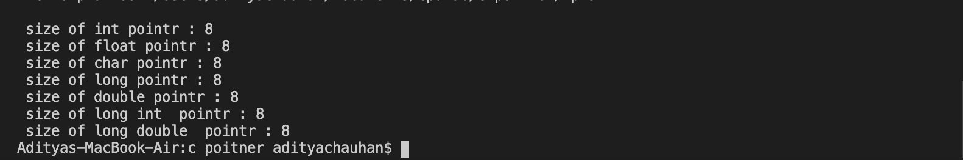

**PRACTICAL-3**

**Aim**-**c program find sum of array element using dynamic memory allocation.**

**Input:-**

#include <stdio.h>

#include<stdlib.h>

int main()

{

int i, n, sum = 0;

int *a;

printf("Enter the size of array a :");

scanf("%d", &n);

a = (int *) malloc(n * sizeof(int));

printf("Enter Elements : \n");

for (i = 0; i < n; i++)

{

scanf("%d", a + i);

}

for (i = 0; i < n; i++)

{

sum = sum + *(a + i);

/* this (a+i) is used to access the value stored at the address*/

}

printf("Sum of all elements in array : %d\n", sum);

return 0;

}

**Output:-**

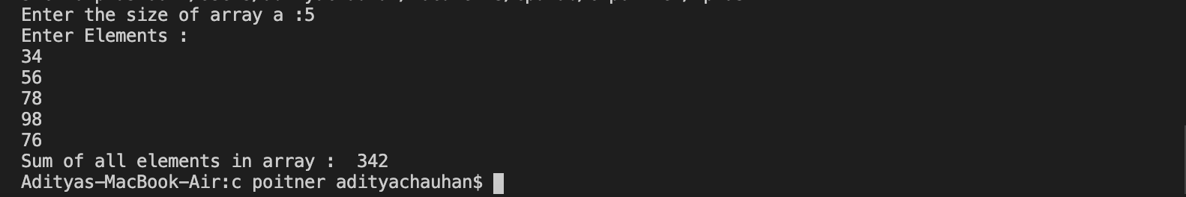

**PRACTICAL-4**

**Aim**-**c program implement call by reference.**

**Input:-**

#include<stdio.h>

void swap(int *a, int *b)

{

int temp;

temp=*a;

*a=*b;

*b=temp;

}

void main()

{

int a,b;

printf("Enter the value of a : ");

scanf("%d",&a);

printf("enter the value of b : ");

scanf("%d",&b);

swap(&a, &b);

printf("\nValue of a: %d",a);

printf("\nValue of b: %d\n",b);

}

**Output:-**

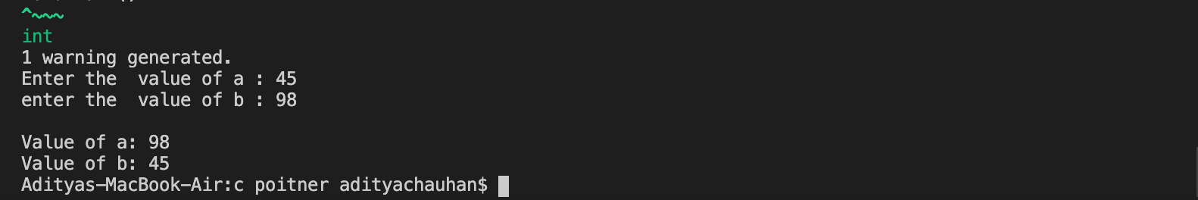

**PRACTICAL-5**

**Aim**-**c program to read and print name,where memory for variable should be declared at run time**

**Input:-**

#include<stdio.h>

#include<stdlib.h>

int main()

{

char *name;

int l;

printf("Enter maximum length of name: ");

scanf("%d",&l);

name=(char*)malloc(l*sizeof(char));

printf("Enter name: ");

getchar();

gets(name);

printf("Hi! %s, How are you?\n",name);

free(name);

return 0;

}

**Output:-**

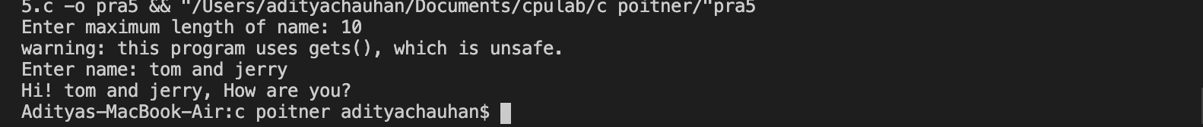

**PRACTICAL-6**

**Aim**-**c program to print string character by character using pointer**

**Input:-**

#include <stdio.h>

int main()

{

char str[100];

char *p;

printf("Enter any string: ");

fgets(str, 100, stdin);

p=str;

printf("The input string is: ");

while(*p!='\0')

printf("%c",*p++);

return 0;

}

**Output:-**



**PRACTICAL-7**

**Aim**-**C program to reverse an array using pointers**

**Input:-**

#include<stdio.h>

#include<stdlib.h>

int main()

{

int size, i, arr[100];

int *ptr;

ptr = &arr[0];

printf("Enter the size of array :: ");

scanf("%d", &size);

printf("\nEnter %d integers into array:\n ", size);

for (i = 0; i < size; i++)

{

printf("\nEnter %d integer into array: ", i+1);

scanf("%d", ptr);

ptr++;

}

ptr = &arr[size - 1];

printf("\nElements of array in reverse order are :\n");

for (i = size - 1; i >= 0; i--) {

printf("\n\nElement %d is %d ", i+1, *ptr);

ptr--;

}

return 0;

}

**Output:-**

